No Name Unity Picnic
*******FREE*******
August 12th, 2017…9am-5pm
Where: Richmond Park, 1101 Richmond SW, Grand Rapids, Michigan, 49504
Games, raffle, Music, Food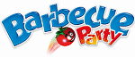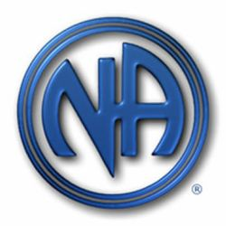

For More Info Contact: Joe W (616) 323-7286 or Charles F (616) 706-4918

