SBASCNA 34th Annual Retreat Fundraiser
Our Compass of Life
Guiding Our Path
February 26, 2022

Card Party and Game Night
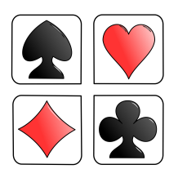
Euchre Tournament

Doors open at 6:30.
The euchre tournament begins promptly at 7:00

Not a euchre player? Bring your favorite board game or card game,
or just come out, socialize, and support a good cause
A one-of-a-kind retreat shirt will be auctioned off!

Zion Evangelical Lutheran Church
Raffle tickets
Ra

545 7th Street
Freedland, MI 48623

Please bring a snack to share
$5.00 Donation
Coffee will be provided --- Pop and water will be sold

Fundraiser for Retreat Scholarship Registrations

Mark your calendars for our final fundraiser
March 19th – St. Patrick’s Day dance

