**SBASCNA MEETING MINUTES**

**September 15th, 2024**

**Freeland, MI**

**OPENING**: Opened at 2:00 pm with a moment of silence followed by the Serenity Prayer.

**READINGS**:

Purpose, Functions, and Responsibilities of ASC - Dave W.

NA World Service Vision - Bryan H.

The 12 Concepts of NA Service - Joshua D.

**NEWCOMERS to AREA**: None

**ROLL CALL:** 15 groups represented *(See attached SBASCNA ATTENDANCE RECORD)*

**ACCEPTANCE of MINUTES**: APPROVED Kim P. / Joshua D.

**NOMINATIONS & ELECTIONS:** None

**OPEN POSITIONS-PLEASE ANNOUNCE AT YOUR HOMEGROUPS:**

**Co-Chair Co-Secretary Co-Treasurer Alt-RCM**

**TRUSTED SERVANTS’ REPORTS**

**CHAIRPERSON/POLICY AND ADMINISTRATION:**

* Guideline changes have been approved, with changes made to two items:
  + Section X Qualifications and Duties of Area Trusted Servants, Number 5 Treasurer, we are adding to the treasurer's duties. *(ix) Responsible for the Financial Responsibility Waiver, to make sure the chair of every subcommittee signs one. The treasurer will also keep track of these documents.* [Financial Responsibility Waiver](https://docs.google.com/document/d/1tSDFd9AxVMzdMYOIYY8N3OdxIYvYo3C4/edit)
  + Section X Qualifications and Duties of Area Trusted Servants, Number 9, Section *(vi) SBASCNA sub-committees are required to purchase all literature and NA merchandise from the SBASCNA Literature Committee. Unless the required items are unavailable then they may be purchased elsewhere.*
* A letter is going to be written to the previous activities chair in regards to the missing prudent reserve.

* New proposed guideline addition to Section V Discussion Limits: *In the event of a heated disagreement during an area meeting, anyone has the right to request a vote (of GSR’s present) to remove a trusted servant from their service position for that meeting.* (Trusted Servants are Chair, Co-Chair, Treasurer, Co-Treasuer, Secretary, Co-Secretary, RCM, and Alt-RCM)

**SECRETARY:** The report is the minutes. If you or any member of NA are not receiving the area minutes and would like too please let me know. Thank you for letting me be of service, Janell K.

**TREASURER:**

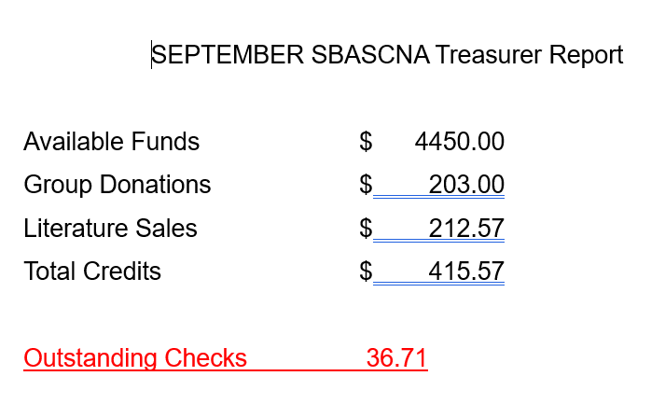

In Loving Service Cathy H.

**RCM:**

Our last Michigan Region meeting was held at Ellens Corner, Mesick Mi Aug 4th2024.

RCM and RCMA were both present. The last reported regional balance was $2272.40. Our region continues to need donations to continue operations. We are awaiting the final financial report from the Michigan Region Convention. There are several service positions open at the regional level if you are interested.

Alt Secretary, Alt Facilitator and Alt Treasurer

“World Convention.” The Power of Love. WCNA 38—29 August through 1 September 2024, at the Walter Washington Convention Center in Washington, DC. Had lower than anticipated participation, with just over 18000 of us in attendance. Finances related to this event are pending but we anticipate shortfalls.

For those interested in ordering speaker tapes from the event,

Use this link to order the full set on CD:

<https://na-speaker.com/wcna-38-the-power-of-love-pre-order-full-convention-full-cd-set.html>

Use this link to order the full set on a convenient custom thumb drive:

<https://na-speaker.com/wcna-38-the-power-of-love-pre-order-full-convention-thumb-drive-customized-usb-card.html>

Mileage Reimbursement Rate MRSCNA is proposing that we change the mileage reimbursement rate from the IRS standard of .65 per mile, back to .40 per mile, or actual receipts for gas.

In regard to next Region,

[Spani](https://es.surveymonkey.com/r/sp_drt_mat_idt_input)Region will be Virtual October 6th @ 9:00 am @

[https://us02web.zoom.us/j/83201875742?pwd=WWtrSkNXYmNNcVhJWEszRGxFbnFvUT0](https://us02web.zoom.us/j/83201875742?pwd=WWtrSkNXYmNNcVhJWEszRGxFbnFvUT09)

ID: 83201875742

Password: MZF1987

In loving service,

Don M. RCM

**SUBCOMMITTEE REPORTS**

**ACTIVITIES:** Next Sub Committee Meeting: October 14th, 2024 5:30 pm before the “Surrender Our Lives” group at 6:30 pm, 4640 N. Michigan in Saginaw.

The last couple of meetings ran smoothly and we got a lot accomplished. The October 14th meeting, we will discuss last minute details for the Halloween Dance & Gratitude Dinner. Hopefully we can also get the basics down for the Sanity Bash so we can put out a flyer right away. We could use more support for the committee since there are only six of us including myself. In Loving Service Linda.

**HOSPITALS & INSTITUTIONS:** Good afternoon family, this is my first report to the area and I have a lot to report. First, I started by contacting Kim S. she gave me information on some of the people actively doing H&I in our Area as well as contact info for Pathways (Health Source) Aaron as well as the day and time the women’s meeting was going in to Tri-cap and the day and time for the Ten16 meeting as well as the day the day the Pathways (Health Source) meeting. And I asked her for the name and contact info for the ladies going in to Tri-cap as well as the people we have going into Pathways (Health Source) Kim informed me that there were currently 3 women going into Tri-cap I later learned of a 4th woman going into tri-cap on Thursdays at 6pm and her and Sonny were doing Ten16 on Tuesdays I thanked her for her service Next, I started to contact some of the facilities to introduce myself and familiarize myself with their needs. I called the contact person at tri-cap Michelle Campbell (Substance Abuse manager). We have had several conversations over the past few weeks. I have gotten a new person into tri-cap Bill V. and he and Mark H. are doing well. We have made a team effort to change the day and time we go into tri-cap to Mondays at 1:30 pm for the men, and the adjustment is going well averaging 15-18 each meeting. We discussed the women’s meeting and it was brought to my attention that Michelle Campbell nor the Director Gary Davis at tri-cap knew that a women’s meeting was taking place at 6 pm on Thursday and I was informed by Michelle that we would need to move to another day I got in touch with the ladies I have currently going into the facility and told them the situation and said that Wednesdays and Fridays were offered to us it seemed that Wednesday at 6 pm was the preferred time for most of the women and will call and set the schedule up Monday. I have been in touch with Aaron the contact person at pathways (health source) and he stated that he was unsure that there was an H&I meeting that was taking place at the facility but he would speak with his Nurses and Counselors to verify but he did remember that a meeting used to take place on Sundays. I told him I remembered the Sunday meeting from years before so I got in contact with Justin W. and he informed me that as many as 6 people are currently going into Pathways (Health Source). I have been in touch with several of these men. As of now things seem to be going well, I asked if they needed literature and paper key tags and at this time their needs are met. I have not had contact with Aaron since our first conversation. I got in touch with the contact person at ten16 Christian and we discussed how things were going at the ten16 she informed me of concerns of smoking, E-cigs, and vapes being a problem with the people coming to the facility as well as contraband being brought in to the meeting this is a concern because they have a no smoking policy for the property and the contraband are things that their clients aren’t allowed to have , I believe that a statement in the opening format might help. I spoke with Kim S. and she recently told me that one of the H&I members would be stepping down as one of the chairs at ten16. I am actively looking for Someone to take his place we currently have 3 people going into ten16 that I’m aware of as well as Chris B. who informed me, he has spoken and chaired on occasion. This meeting is open to the public by the facility and has had a strong following in the past I’d like to see that happen again.

I spoke with Duane at the Ogemaw County correctional facility (west branch jail) Duane gave me a list of the people currently going into the facility we currently have three including Duane and Duane informed me that unfortunately the jail was scheduled to be closed at the end of September due to budget constraints. I decided to do my due diligence and contact the jail Duane had given me the info on the contact person at the jail Lt. Howard. I was told that I had to speak with the Sheriff Brian Gilbert to verify the information and was given the contact info for the sheriff, I called and spoke with the undersheriff Paul Frechette, I was able to verify that the information was correct. I asked how long we would be able to hold meetings in the facility and was told most likely till the end of September I said to the undersheriff that if they needed us to come back in the future to please contact me he thanked me and said he would. I got a hold of Jeffery D. Williams (CEO, and founder of DOT Treatment Facility) he put me in touch with his son Jeffery Williams and I was told that at this time Mondays and Wednesdays were unavailable but he was open the rest of the week at 7 pm I’m planning on calling my H&I members I’m currently waiting to schedule people to go in to DOT. I have had some trouble with contacting Capt. Stewart however he did leave me a message Friday and gave me his direct line, so I plan on calling him Monday. The meetings are going well, there is active participation, and we are averaging nearly 20 attendees on a bye weekly basis. We currently have 19 members actively doing H&I in the Saginaw Bay area. Duane said he would look into possibly contacting the Roscommon County jail after the west branch jail closes. I am planning on calling Roscommon County jail in the future. I have read the H&I Handbook from world as well as the guidelines for this Areas H&I Subcommittee and am currently reading the PR Handbook i would like to know if it’s at all possible since I’m ordering all of my literature from Area that the H&I subcommittee doesn’t need the prudent reserve with the exception of the paper key tags which I have been in contact with NAWS, rep. Jennifer Underling which put me in touch with a gentleman by the name of Steve at NAWS. When I contacted him, he sent me an Email with the hyperlink to the Artwork for the paper key tags. If we wish to print them off ourselves, I’d like to discuss this in new business if possible. I’ve made and given a literature order to Peggy the literature chair and sent an Email copy to [saginawlit@gmail.com](mailto:saginawlit@gmail.com) of 195.60 cents thank you. The H&I subcommittee have also received 20 introductory guides to Narcotics Anonymous from Brian H. that were ordered for H&I before Covid-19 and ordered an additional 17 introductory to narcotics anonymous booklets, 90-day paper key tags, and 30-day paper key tags with tax and shipping comes to a total of $79.52 total from MSO and am hoping for reimbursement for those orders. There are itemized receipts for the materials purchased available. If this is not possible, I understand ILS. Josh D.

**LITERATURE:** There have been some small price changes, a new order form has been placed on the website. Please be sure you are using the new one. For example, some pamphlets have gone from 23 cents to 25.

This month I did not place the order but Shane did to show me how. The order placed was for $586.40 - $35 for a balance owed of $551.40 due. I have two orders for October and 1 order from this month needs 7 more “Just For Today” meditation books. So not bad for my first time filing orders. ILS, Peg M.

**NEWCOMER EVENT:** We are working out the final details of the newcomer event. At our last meeting the committee members signed up time slots for service commitments at the event. We are still working on inviting all of the local (and not local) treatment centers, outpatient facilities and sober living facilities to the event. We spent $25 this month at staples to print flyers for the Newcomer event. Our treasury is now at $1,342. We have planned to purchase pizzas, cookie trays and ingredients for salad for our lunch. We plan to spend between $350-$400 all on food and bottled water. I will be paying Messiah Lutheran Church $240 for rent, coffee and cleaning fees. We are also purchasing Basic Texts and IP’s to give away at the event. I will give a detailed financial report and hand in receipts next month. Our next committee meeting is September 27th at 7:30 pm at Midland Reformed church in Midland. Anyone interested in helping with the event please attend our next meeting! Please take flyers to your homegroups and announce this event!

ILS, Amanda M and Dana S

**PUBLIC RELATIONS:** Next Committee Meeting: Wed Oct 9th , Midland following the How it Works group meeting (~7:50pm)also on Zoom using the How it Works group meeting code (236328539)

Two members attended the September PR meeting (on Zoom). The website is current. On October 10 th we

will be participating in the Mental Health Fair at Delta College. I forgot to order a new stamp for the PR

Subcommittee, but will do so this week. Please email all changes to meeting times and/or locations (as well as

event flyers) to myself or the web servant. If you have an event flyer please attach an original electronic

document (not simply a picture/screenshot of it). All flyers must have the name of the home group or

subcommittee which is sponsoring the event printed on the flyer.

Bryan H.

NAJFT@mudboy.net

**RETREAT:** Next Committee Meeting September 17th, 2024. 6pm before the Survival group. The new committee will have 1st meeting on September 17th. The final report for 2024 is included and shows the allocation for the $4,586.52 currently in the bank. In Loving Service Tim S.

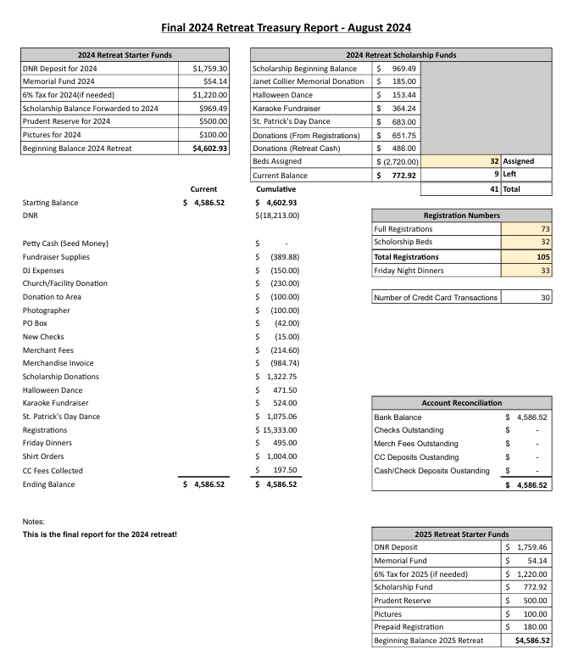

**GROUP REPORTS**

**A GATHERING OF MEN AND WOMEN (Saginaw):** Group donation $10. Next business meeting October 10th, 2024. Starting October 6th, 2024 NA meeting will be moving to Saginaw Recovery House 1506 Mackinaw St. Meeting time is still 9am to 10:15am. ILS, Linda.

**COMMON GROUND (West Branch):** Group Donation $30. Business meetings are the Tuesday before Area. Meetings are going well with 10-12 people in attendance. ILS, Duane

**COMMON WELFARE (Bay City):** Next business meeting October 17th, 2024. All is well but attendance is down, no donation for area. ILS, Josh D.

**DOWN WITH DISEASE (Midland):** Business meetings are the Saturday before Area directly after the 10am meeting. Our group would like clarification in the guidelines about it being sub-committees that need to order literature from area. Attendance is going well. ILS, Janell K.

**HOW IT WORKS (Midland):** Next Business Meeting October 16th, 2024. We wonder who is responsible for making sure that the financial responsibility forms are signed/dated by trusted servants, and who/where are the signed forms kept? We also suggested adding the word “subcommittee” to the literature section of the Subcommittee Chair Duties (ie, “1) All literature distributed on behalf of SBASCNA subcommittees needs to be stamped with the SBASCNA stamp” ILS, Bryan H.

**HUGS NOT DRUGS (St Helen):** Group Donation $45Next business meeting 10.11.24 Attendance has been slightly up this month. We still have our 4 to 6 regular members mixed with some people visiting from out of town. As always, we invite anyone visiting the area to attend our meetings. We will continue to support our area even if we are not in attendance at area meetings. ILS, Gloria H.

**JUST FOR TUESDAY (Midland):** Next business meeting September 24th, 2024 at 8:30pm. Our group voted yes to all proposed area guidelines except the financial responsibility form/waiver. We vote no on this. ILS, Dana.

**JUST STAY (Midland):** Next business meeting October 19th, 2024. ILS, Rick W.

**RECOVERY NATION (West Branch):** Group Donation $20. Next Business Meeting 10-19-24. Eating meetings are going well. 2nd Saturday of each month is a speaker meeting with food and open. Donations are down a bit. ILS, Glen.

**SURRENDER OUR LIVES (Saginaw):** Group Donation $50. Next business meeting October 7th, 2024. We will be back inside when weather gets colder. ILS, Kim S.

**SURVIVAL (Saginaw):** Group Donation $25. Next Business Meeting 09-24-24. ILS, Gina H.

**OLD BUSINESS:**

* None

**NEW BUSINESS:**

* H&I, did area wish to continue to get paper key tags from MSO?
* New proposed guideline addition to Section V Discussion Limits: *In the event of a heated disagreement during an area meeting, anyone has the right to request a vote (of GSR’s present) to remove a trusted servant from their service position for that meeting.* (Trusted Servants are Chair, Co-Chair, Treasurer, Co-Treasuer, Secretary, Co-Secretary, RCM, and Alt-RCM)

**OPEN FLOOR**:

* Susan S.: Gladwin is in dire need of some support. Those meetings are on the verge of shutting down. They are discussing options such as changing meeting times or days. 1312 N. State St. Gladwin, MI 48624 Tuesdays and Thursdays at 6:30pm.
* Drae R.: Would Area be interested in purchasing a camera to make the area more accessible to people on zoom?
  + The issues include using a basic laptop, church’s wifi, and we struggle with getting the speaker and zoom to function fully.
  + Drea will look into what Region is currently using, and report back to us.
  + The laptop camera is functional we will have that turned on moving forward.

**FLYERS & MEETINGS:** If any committees have flyers or meetings, they would like posted to the SBASCNA Website send to [**SaginawBayArea@Michigan-NA.org**](mailto:SaginawBayArea@Michigan-NA.org) (PDF FORMAT)

**LITERATURE ORDERS:** [SaginawLit@gmail.com](mailto:SaginawLit@gmail.com) **Your orders need to be submitted prior to each area for orders to be filled.** [**SBASCNA Website**](https://michigan-na.org/saginaw-bay-area/)*click here to locate the online order forms.*

Next Sub-Committee Meetings: Want to get involved in a Committee here’s how.

|  |
| --- |
| **Activities:** October 14th, 2024 5:30pm before “Surrender Our Lives” group at 6:30pm, 4640 N. Michigan. Saginaw. |

|  |
| --- |
| **H**ospitals **& I**nstitutions: Monday October 7th, 2024 7pm Alice and Jack Wirt Public Library Room #4 500 Center Avenue Bay city, MI 48708 |

|  |
| --- |
| **Literature:** Sunday October 20th, 2024 immediately following Area. |

|  |
| --- |
| **Newcomer Event:** Friday September 27th, 2024. 730pm Midland Reformed Church 1100 N. Saginaw Rd. immediately following the 6pm Down with Disease Meeting |

|  |
| --- |
| **Policy & Administration:** October 20th, 2024 1pm Zion Lutheran Church 545 7th Street, Freeland, MI 48623 |

|  |
| --- |
| **Public Relations**: Wednesday October 9th, Midland following the How it Works group meeting (~7:50pm) 2808 Waldo Ave, Midland also on Zoom using the How it Works group meeting code (236328539) |

|  |
| --- |
| **Retreat**: September 17th, 2024 at 6pm prior to Survival Meeting in Saginaw. |

|  |
| --- |
| **Next Area Meeting**: **S**aginaw **B**ay **A**rea **S**ervice **C**ommittee of **N**arcotics **A**nonymous - Third Sunday of every month  October 20th, 2024 - 2pm - Zion Lutheran Church 545 7th Street, Freeland, MI 48623 |

**Announce at Homegroups before October 20th, 2024**

1. Open positions: *We would like to get these filled, the sooner the better.* 
   1. Co-Chair
   2. Co-Treasurer
   3. Co-Secretary
   4. Alt-RCM
2. New proposed guideline addition to Section V Discussion Limits: *In the event of a heated disagreement during an area meeting, anyone has the right to request a vote (of GSR’s present) to remove a trusted servant from their service position for that meeting.* (Trusted Servants are Chair, Co-Chair, Treasurer, Co-Treasurer, Secretary, Co-Secretary, RCM, and Alt-RCM)

We are asking the homegroups to discuss this and let area know your thoughts? Is this something you want your GSR (Group Service Representative) to vote on? If your **G**roup **S**ervice **R**epresentative is unable to come to Area in person or you need clarification feel free to email [secretarysaginawbay@gmail.com](mailto:secretarysaginawbay@gmail.com).