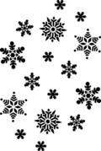
New Hope Group of
Narcotics Anonymous
Presents:
the Annual Holiday Celebration

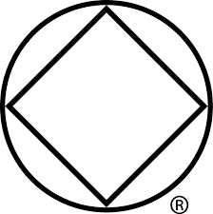

Sunday, 6PM – 8PM, December 16th, 2018
North Park Reformed Church
1316 Barney Rd., Kalamazoo, MI
Where Barney, Mosel, and Douglas intersect

Bring a Dish to Pass – No Addict Turned Away

