WINTER WONDERLAND BLAST!
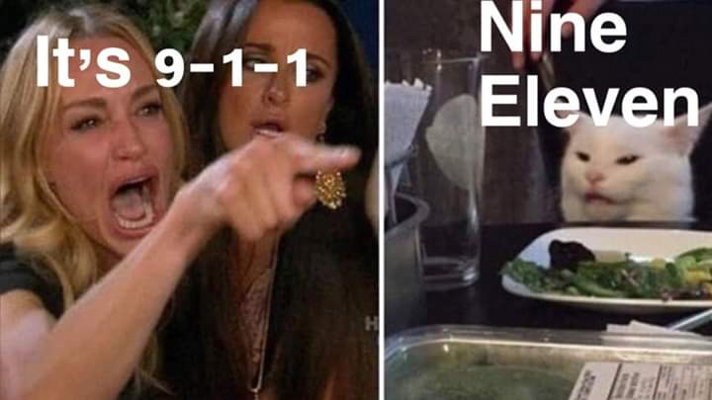

WHEN: December 15th, 4 PM to 8PM
WHERE: EASTWOOD HOUSE OF RECOVERY
(2049 E Michigan Ave, Kalamazoo, MI)
SPEAKERS: Tony S. & Nancy V.
Food & Fellowship & Possibly Karaoke!
$5 donation / no addict turned away
Narcotics Anonymous is not affiliated with any facility.

