BWASC January Meeting Minutes

Opening Statements:

Discussion to take BWASC Budget back to the groups before approval.

**Administrative Reports:**

**Secretary:** BWASC Chairperson drew up December minutes, nobody to take on the secretary position at this time. Secretary stepped down and turned over all the related material to the chairperson. Co-secretary position is also open. *Report approved*

**Treasurer:** Treasurer stepped down, turned over financial books to co-treasurer, Linn B. December’s report was completed by Linn.

*Starting Balance: $575.45*

Previous treasurer has been removed from the BWASC account, and now in possession of a new ATM card for the account. Linn B is the only name on the account at this time. 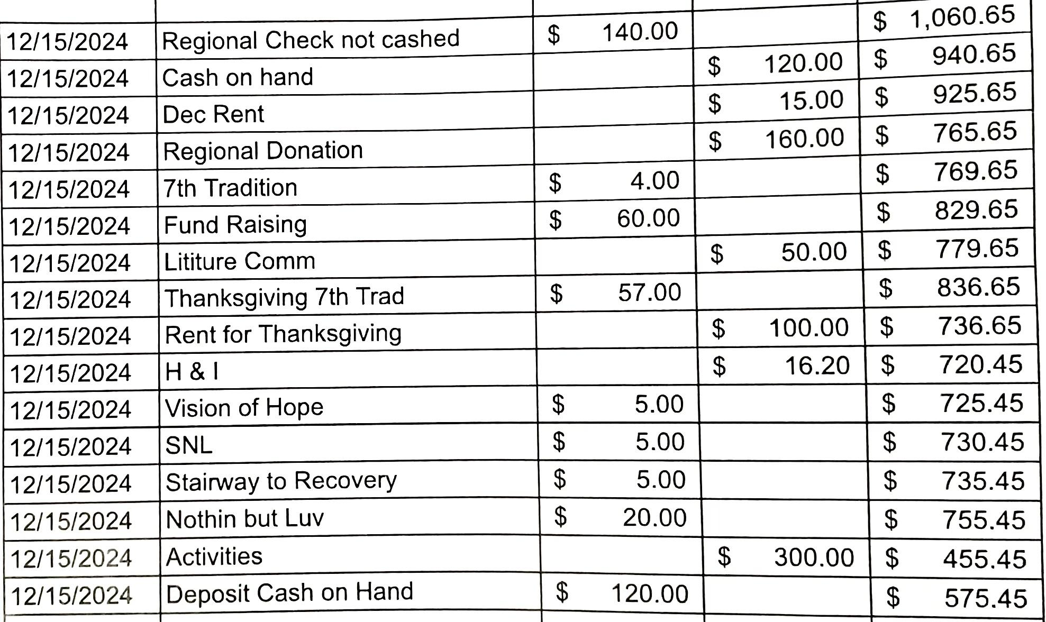

*Report Accepted*

**RCM:** MDRNA meets Jan 26

**Subcommittee Reports**

**Helpline:** Workshop Feb 19 at Grace 6:30pm, regional helpline needs help. Blue Water has 4 volunteers.

**A&E:** Donated $773.68, handed over budget breakdown to the treasurer, and requested $150 for pancake breakfast event on Feb. 15 at 10:30 at St. John’s church, 710 Pine. Flyer posted on the BWANA website.

**H&I:** Change subcommittee meeting to 2nd and 4th Saturday, at St John’s church, 710 Pine, directly after the A&E, approx 2pm. Expressed an issue that was handled at the Clearview facility with one of the members that attended. Requested $35 for literature for the jail. Clean time requirement for the jail has been decreased to 2 years, must meet criteria such as 3 years off paper, no warrants, fines, etc.

**Webservant:** Updated meeting lists. Still need to change H&I meeting time and location. Added events to the website. Non-vaping meetings have been added to formats. Email has been updated to [webservant@bluewater-na.org](mailto:webservant@bluewater-na.org) to send flyers and updates for the website. Region is paying for the Google Workspace.

**Archives:** Received some flyers from inactive groups. Macomb Miracles newsletter put in their most recent newsletter, a section to contact Linn with archives for the BWANA.

**Meeting Lists:** Printed 125 meeting lists, was not informed that she could not print them herself. Will be reflected on the Feb treasurer report.

**Literature:** Bank is fully stocked. Have groups prepay and submit literature requests at the area meeting each month.

**Fundraising:** Waiting to hear back from St. John’s church about the damage to the church from the last event to send that information to the region to make an insurance claim, if insurance will not cover, fundraising will do its best to help the area pay for the damages. Fundraising will dissolve after prudent reserve is met.

**GSR Reports:**  Business was conducted first, meeting ran late and written reports were submitted to the chairperson for the minutes.

**Morning Reflections:** Needs trusted servants, church has had muliple complaints about vaping.

**Young in Recovery:** *Absent/ Not Active*

**Bridge to Recovery:** *Absent/ Not Active*

**Stairway to Recovery:** No report $5 donation

**Surrender on Sixth:** *Absent/ Not Active*

**Nothing but Love:** No report $20 donation

**Rather Unique:** Kim T open talk, unsure of the date.

**Project Return:** No report

**Courage & Hope:** No report $10 donation

**Saturday Night Live:** *Absent* Gave Area chair $5 donation

**JFT (Zoom):** No report

**Vision of Hope:** *Absent*

**Awesomeness:** No report, requested $50 start up costs.

**Reach for the Beach:** Building treasury, needs support, 5-7 in attendance.

**Old Business:**

**Motion:** To change the area flyer from zoom to google meets. Since we are already using it. *Tabled*

Discussion of the Policy Chair position needs to be added to the guidelines if vote passes. Adhoc guidelines committee to be scheduled for 2/9/25 @ 4:00pm

**New Business:**

BWANA mailbox no longer at BWROC, motion to move mailbox to the dry dock for $10 a year. 412 Huron, Port Huron, MI 48060.

**Open Service Positions:** Secretary, Co-secretary, Treasurer, Bill G nominated and accepted the nomination, Linn B will continue as Co-treasurer. Public relations, Primo (Awesomeness) expresses interest when he has 6 months. Outreach is also open. Electronic meeting subcommittee, Brittany H expresses willingness.

Chairperson expresses that he will be having surgery in the near future and will not be able to chair or attend the ASC during his recovery time.

Brittany H officially voted in for the meeting list subcommittee.

**Ending Treasurer Report:**

Started off with $575.76, 7th tradition was $8. Co-treasurer stated that the ending balance was $1,382.44.