**December BWASC Minutes**

**New GSRs:**

Bill G, Reach for the Beach. Brittany H, Rather Unique. Adam, Nothing but Love. Jessica T, NA meeting of Awesomeness.

**Admin Reports:**

**Treasurer:** Starting balance: $940.65, $120 cash on hand, total of 1060.65. Budget proposal:

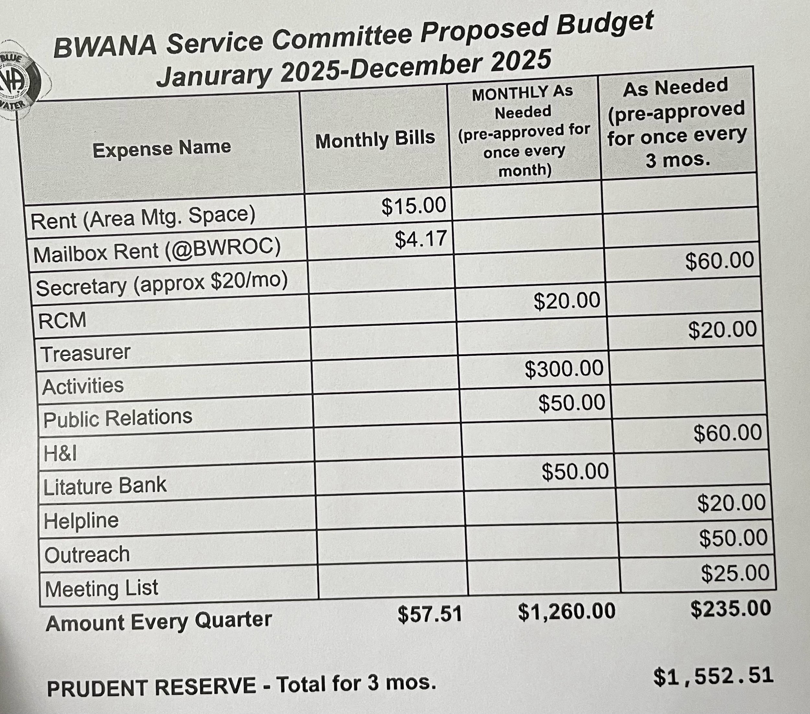

*Budget Approved.*

*Report Approved*

**Co-Treasurer:** Collects 7th Tradition

**RCM:** Regional Picnic planning for 2025, Chair of the sub-committee elected, Dave M.

Revising the region bi-laws. Plans to change the meeting date for Metro Detroit to odd months to avoid holidays. MDRCNA fundraiser in BWANA planning. RCM forgot to pick up the check for Region ($140), RCM to pick up additional $20 and check for the regional donation. *Report Accepted.*

**Secretary:** *Absent*

**Sub-Committee Reports:**

**Helpline:** 4 volunteers, printing more flyers, and planning a workshop with pizza. Regional Helpline in need of volunteers as well.

**Website:** Updated meeting locations, removed closed meetings (as of Dec.). Email addresses drawn up for admin positions. Proposal of Google Workspace.

**Meeting Lists:** 125 meeting lists

**Archives:** No paperwork or flyers received yet, needs closed meeting flyers. Received older meeting info and guidelines for Blue Water NA convention, collecting past history for “History of BWANA” project.

**Fundraising:** $60 donation for T-shirt sales.

**Thanksgiving Ad-hoc:**  Marathon meeting took place, alot of attendance and service. $57 generated. Requested $43 for the remainder of the rent due for the Dry Dock.

**Literature:** *Dave Voted in-* Starting Balance of $193.12 after purchasing literature balance is at $9.53. Requesting $50 from the budget

**H&I:** *Megan Voted in-* Meets every 2nd and 4th Friday at 6:30, Grace Church. 5 in attendance. Goes to Clearview Treatment Center every 1st Friday. Discussion of reaching out to Sacred Heart. Requested $16.20. Discussion of moving sub-committee meetings to handicap accessible location.

**A&E:** *Jessica T Voted in-* New Year’s Eve masquerade and Xmas Eve marathon meeting. Requesting $300 allowance.

.

**GSR Reports:**

**Morning Reflections:** $0 donation, open talk 12/24 at the Dry Dock.

**Bridge to Recovery:** *Absent*

**Rather Unique:** 30-40 attendance, Elle B open talk and ugly Christmas sweater contest 12/24. Will be closed on NYE.

**Courage and Hope:** Attendance, 18-23, $0 donation, low funds.

**Young in Recovery:** *Absent*

**NA meeting of Awesomeness:** Time changed to 5:30, moved to Grace church, $0, low funds

**Project Return:** *Absent*

**Step Up:** *Absent*

**Vision of Hope:** Avg attendance, 50 people. $5 donation.

**Saturday Night Live:** 35-50 in attendance, $5 donation. Q&A Panel on 1/18

**Stairway to Recovery:** Attendance 12-20, $5 donation. In need of trusted servants.

**Nothing but Love:** Attendance avg 20, $20 donation.

**Just for Today Zoom:** 25-40 in attendance, nominating Michael B for Policy chairperson. Donated $100 to NA meeting of Awesomeness.

**Surrender on Sixth:** *Absent*

**H.O.W:** Nobody is coming, the meeting is struggling, likely closing down.

**Reach for the Beach:** First meeting, 7 attended, 3 trusted servants made 1 year commitment. Fridays at 7pm. 111 W. BLVD, Marine City. May-Sep to meet at the beach.

**Old Business:**

**Elections:** Jessica T voted into A&E, Dave O voted in for Literature, Megan L voted in for H&I, Jeannie R voted in for RCM, point of discussion in regards of Policy chairperson, nomination of Michael B, 9 ½ years in recovery, homegroup is Just for Today zoom meeting, working knowledge of concepts, traditions, and steps. Discussion to change guidelines to allow someone other than RCM to write policy. No other nominations. Open positions: Treasurer, Co-Treasurer, Co-Secretary, Meeting lists, MSO board, Vice Chair. Bobbie Jo stepped down for treasurer position. Brittany H to be nominated for Meeting Lists next month, when she meets the clean time requirement. Discussion of electronic meeting chair.

**New Business:**

Discussion of BWANA Newsletter.

**Motions:**

RCM submits a motion stating: “To have all area reports to be distributed via email using the Google Workspace.” *Motion Passes*

RCM submits a motion stating: “To use the Google Workspace/Google Meets for all Area and Regional business, including Area reports and virtual meetings.” *Motion Tabled*

**Closing Statements:**

Next meeting 1/19/2025

Ending Treasurer’s Balance: $575.76