SOUTHWEST MICHIGAN AREA OF NARCOTICS ANONYMOUS SERVICE COMMITTEE MEETING MINUTES
AUGUST 25, 2024
AGENDA
- Moment of Silence: Derek
- Service Prayer: Kim
- Traditions: Michael
- Concepts: Marcus
- Roll Call: Emily

Present Committee Members:
Position | Name | Present/Absent | Position | Name | Present/Absent
CHAIR: | Uriah C. | A | RCM | Brian C. | P
CO-CHAIR: | Derek | P | RCMA: | OPEN | NA
SECRETARY: | Emily N. | P | PR | Kim G. | P
CO-SECRETARY: | Samantha | A | CO-PR | OPEN | NA
TREASURER: | Stacey R. | P | Outreach | David H. | P
CO-TREASURER: | Angleline S. | P | ACTIVITIES: | OPEN | NA
LITERATURE: | Patti K. | P | H&I | Dameion G. | P
CO-LITERATURE: | OPEN | NA | CO-H&I | Steve-o L. | P

Present Home groups:

Group Name | GSR/GSRA | Present or Absent
2nd Chances | Eric
911 | Brian C. | P
A New Way | David H.
Acceptance | Kim G. | P
Against All Odds | Stacey | P
Any Lengths | Patti K. | P
Believers | Scott C. | P
Buchanan Fellowship | Todd L.
Choices | Mike
Daughters of Hope
Dinosaurs | LeRoy
Early Birds
Feel the Love
Freedom | Earnest | P
Insomniacs | Ryan | P
Keep Coming Back | Craig
Ladie's Night | Patti K. | P
Let's Stay Together | Antonio | P
More will be Revealed
Never Again | Rick
New Beginnings | Danielle | P
New Hope | LeRoy
New Life | Joe
Night Owls
North Side | Susan
Nothing to Fear | Emily N. | P
Pathfinders | Kristina
Peace of Mind | Neil | P
Recovery in the Vine | Matt | P
Similarities | Steve-o L. | P
Solutions | Derek | P
South Side Group | Tarsha
Step Sisters
Steppin' Up | Darren C. | P
Subject to Change | Kevin H.
Unconditional Love | Dameion G. | P
Unity | Paul P. | P
You’re Not Alone | Vic K. | P

- Open Sharing:
- Freedom Group: Will be re-starting after it was closed for the COVID-19 Pandemic. The group will be held at the First Congregational Church in downtown Kalamazoo at the corner of North Park St. and West Michigan Ave. The date and time are still being finalized. More will be revealed.
- Insomniacs Group of NA: This is a New Group starting on September 7, 2024. This meeting will be on Saturday Nights from 11:00pm until 12:30am. It will be held at 1934 South 17th St., Niles, MI, 49120 – in Ryan and Kayce’s Garage. Occasional Campfire meetings (weather permitting), smoking permitted, open meeting (all welcome), group conscience topic based (subject to change). For information or directions, contact Kayce E (574) 386-0092, Kayce12.ke@gmail.com or Ryan L (269) 259-1860, Ryanlutin@gmail.com
- Acceptance Group: All meetings will be **one hour** moving forward.
- Believers Group 8th Annual Pig Roast: This shin-dig is happening October 5, 2024. Bring your favorite dish to pass, $5 suggested donation, no addict turned away. Food served at 2pm. At the Comstock Community Center. Text or call T.J. at 269-883-7444 for more information.

- Approval of Prior Months Minutes: Approved

- Chair Report: Derek: None

- Secretary Report: Emily: I brought 500 meeting lists to the Area meeting this month and brought the majority of them home with me. I did meet up with Dameion from the H&I sub-committee and he took a lot of them for distribution throughout the treatment and detention centers around the area. I also retained some to have for the NA tables that we are going to have set up at the upcoming events for Recovery Month. These are both taking place in Bronson Park on September 14th and 21st. More will be revealed about these events in section 12a. of these minutes.

- Treasurer Report: Stacey:
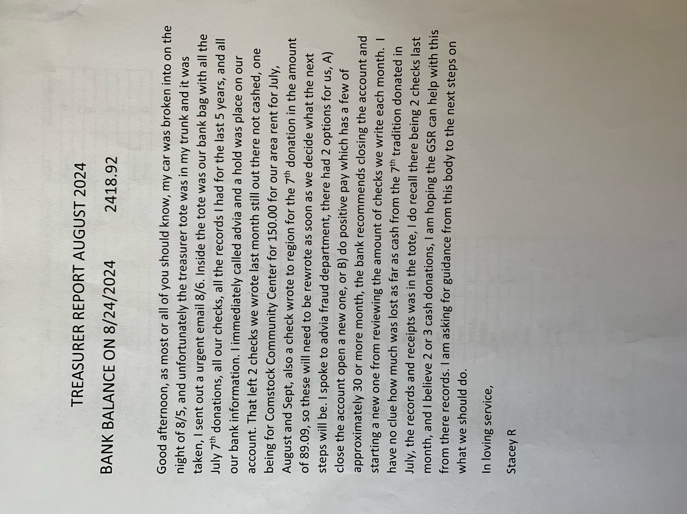

- RCM: Brian:
Greetings from the Michigan Regional Service Body. We met live on August 4, 2024 in Mesick Michigan. Due to the long travel distance, I went up the night before, and am seeking reimbursement for gas and lodging in the amount of $53.10 for gas and $184.00 for lodging. This hotel was a two star hotel, and I thought that was a generous rating.
We learned at the regional meeting that there were 13,810 people registered for the world.
The financial report for the MRCNA convention was given. There was some confusion about the report, but it appears the convention had a profit of around $5500. The Northwoods Area has submitted a bid to host the Michigan Regional Convention in 2026 and 2027 at Shanty Creek in Belair, Michigan.
The Regional body has asked the ASC’s to vote on a motion to change the mileage reimbursement rate back from $0.65/mile to $0.40/mile. *APPROVED*

- Sub-committee

- Public Relations: (PR): Kim:
August 2024 PR Report

Area PR
September is National Recovery Month! Here are some events that we are registered to host an NA table at:

9/7/24: Recovery Month & Suicide Prevention Color Walk, Cass County COA, 10am - 2pm. NA members: Kim G, Ken T, Steve-O

9/14/24: Recovery Institute’s Recovery Fair, Bronson Park, 11am - 3pm
I have registered NA for this event, the discounted cost was $40 (to be reimbursed). NA members: Kim G, Rebecca P, Scott C, Emily

9/21/24: Gryphon Place Suicide Prevention Walk, Bronson Park, 10am Kickoff I have registered NA for this free event. NA members: Kim G, Scott C, Emily

9/28/2024: Carol’s Hope Recovery Life Rally, Carol’s Hope St. Joseph, 11am-3pm. NA members from Doug D’s home group.

- Hospitals and Institutions: (H&I): Dameion & Steve-o:

Southwest Michigan H&I Chair Report – Re-print from July No New August Report
- Men’s and Women’s K-Pep in Kalamazoo on Chicago St. really needs volunteers who have the willingness to come I and carry the message of recovery. Please call or text Dameion at 269-348-6103. He goes up there a lot to make sure the residents have supplies. He has two recovering addict females doing meetings once a month. The male residents are holding their own meetings, and they would really like some recovering addicts to come in to assist with meetings.
- Kalamazoo County Jail is also in need of Male and Female volunteers who have the willingness to do H&I service. If you are interested please call Nick H. at 269-509-7272 for the male side and Trina H. at 269-248-2961 for the female side.
- Gilmore Treatment Center – From Kat C.: Coordinator: Hi Family, I’m and addict named Kat. Things have been going well at H&I. We finally have enough addicts to cover the schedule for both Friday and Sunday. However it would be such a blessing to have additional people as fill-ins meaning alternates in case of call-ins.

- Literature: Patti:
S.W.M.A.S.C.N.A
Southwest Michigan Area Service Committee of Narcotics Anonymous
Literature Report
Meeting Location: Dowagiac
Committee Meeting Day / Time: 7/28/2024 3:00PM
CONTACT INFORMATION
CHAIR: Patti K PHONE: 269-806-3142 EMAIL: swmich.literature@michigan-na.org or
mspattik@yahoo.com
Last month’s sales equaled: $
Literature Purchased last month: $ 1159.91
MSO $ 921.00
Shipping $81.13
IP Discount $21.80
Bulk Discount $48.68
Tax $48.71
Total Order $981.35
Bank $347.71
Cash Box $233.00
Total Money: $580.71
Literature Value $3750.00
Hello Family: Happy Sunday to you all. Hello… Ok well The numbers up top are what the 2 MSO order invoices reflected. I had to place a other order and quite frankly I think I clusterfucked them. Numbers on the invoices don’t add up so I couldn’t make it make sense. I was not charged shipping in the second order however I believe that is where they balanced the difference in the bulk discount and tax last time. The orders come quite quickly and always right on. So I will straighten the invoice discrepancy out … I just found it this morning because I am a great procrastinator.
Thank you everyone for your orders in advance. I do have a few books with me. I do not have it works how and why … I am out. I will be placing that on the next order. Not sure how that happened honestly…I seem always miss something. You would think I would an old pro at this. Just goes to show ya I am human&gt; The new survival kit will be at the world convention. I am not sure how much they will be. I know they are at a discounted rate at the world. So if yall want to take a look at it and let me know if I should order them that would be great. Further more I have asked an addict to grab me one while hes there for myself so if no one gets a look hopefully they wont sell out and I will get to see personally what they are all about. I am excited for a different way to go through the steps. Have I told you all lately how grateful I am for serving this area?
I am grateful for all you and your service.
Also below are the web addresses of our website and meeting list.
Website: https://michigan-na.org/southwest-michigan-area/
Meeting List: https://michigan-na.org/southwest-michigan-area/meetings/
ILS, Patti K

- Outreach: David:

Hello,
I’ve have given out two starter kits for new/returning groups. One was for the Freedom Group in Kalamazoo, looking to start doing meetings again on Wednesdays and is still in the planning stages, and another was for the Insomniac’s Group in Niles. They will be meeting on Saturday’s at 11:00pm beginning, 9/7/2024. I have attached their flyer to this report below.
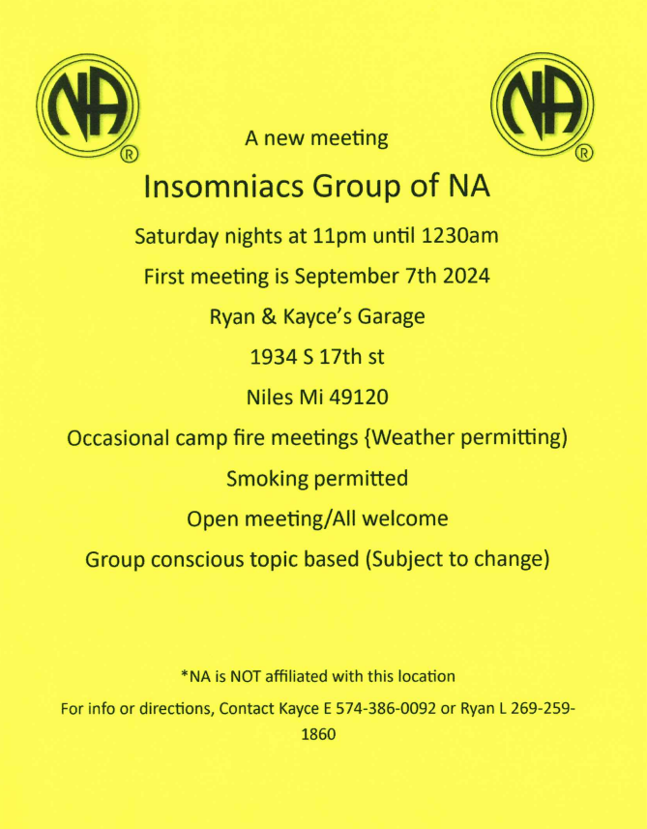

As we get closer to elections, I will be looking for a replacement for the Outreach position for the next cycle. During the last area meeting I nominated Darren C. out of Three Rivers for the Outreach position. He says that he must do some thinking about it yet and will let the body know more information later. I will continue to follow up with him and find alternate options.

I have a new homegroup (Conscious Contact) that meets on Wednesday Nights from 6:00pm to 7:30pm that I’m active in and often must open for and chair the meeting. I’m going to also be attending Battle Creek Area service committee meetings in the future and think that it would be a conflict to do service in both areas. The Conscious Contact meeting is also the only open meditation NA meeting in the area and has been spiritually fulfilling for my personal recovery. I have also been needing to find more balance in my life and in my daily schedule. I can see the good things I’ve brought to this position during my time in it and really wanted to do more. Between school, buying a house, full-time at work, and other service commitments I haven’t been able to make the time needed to adequately serve at this capacity. It’s better for me to let it go to someone who can instead of holding us back.
Thank you for your time, your grace, and your understanding -and I will see you all at the next meeting and report again then.
Best,
David H.

- Activities: OPEN:

- Old Business:

- Nominations for next year’s (2025’s) SWMANA Committee will start today and continue during next months meeting.

- Next Quarters Meetings (October, November and December) will be held in Three Rivers at 321 N. Main St., Three Rivers, MI at the Trinity Episcopal Church.

- New Home Group Report Sheet Approval: Approved: The new report sheet will be available for GSR’s to take back to their Home Groups and trial at September’s SWMANA Meeting.

- New Business:

- Proposal to change mileage reimbursement at the Regional Level back to $0.40/mile from $0.65/mile: Approved: Brian will take this consensus vote back to Region at their next meeting.

- Home Group Reports:

- Home group reports are available in the PDF file that is attached to the email where these minutes are found.

- Close with a moment of silence and the We version of the Serenity Prayer.

