**SOUTHWEST MICHIGAN AREA OF NARCOTICS ANONYMOUS SERVICE COMMITTEE MEETING MINUTES**

**JULY 28, 2024**

**AGENDA**

1. Moment of Silence: Derek
2. Service Prayer: Cinco
3. Traditions: Chris
4. Concepts: Jordan
5. Roll Call: Emily

|  |  |  |  |  |  |
| --- | --- | --- | --- | --- | --- |
| **Position** | **Name** | **Present/Absent** | **Position** | **Name** | **Present/Absent** |
| **CHAIR:** | Uriah C. | A | RCM | Brian C. | A |
| CO-CHAIR: | Derek | P | RCMA: | OPEN | NA |
| SECRETARY: | Emily N. | P | PR | Kim G. | A |
| CO-SECRETARY: | Samantha | P | CO-PR | OPEN | NA |
| TREASURER: | Stacey R. | P | **Outreach** | David H. | P |
| CO-TREASURER: | Angleline S. | P | ACTIVITIES: | OPEN | NA |
| LITERATURE: | Patti K. | P | H&I | Dameion G. | P |
| CO-LITERATURE: | OPEN | NA | CO-H&I | Steve-o L. | A |

|  |  |  |  |  |  |  |  |  |  |  |  |  |  |
| --- | --- | --- | --- | --- | --- | --- | --- | --- | --- | --- | --- | --- | --- |
| |  |  |  |  |  |  | | --- | --- | --- | --- | --- | --- | | **Attendees present that are not GSR or Officers:** |  |  | Chris, Jordan, Cinco, Scott, Big Joe, Eric |  |  | | | |  |  |  |  |  |
| **Present Home groups:** | | |  |  |  |  |  |
| **Group Name** | **GSR/GSRA** | **Present or Absent** |
|  |  |  |
| **2nd Chances** | **Eric** |  |
| **911** | **Brian C.** |  |
| **A New Way** | **David H.** |  |
| **Acceptance** | **Kim G.** |  |
| **Against All odds** | **Stacey** | **P** |
| **Any Lengths** | **Patti K.** | **P** |
| **Believers** | **Scott C.** | **P** |
| **Buchanan Fellowship** | **Todd L.** |  |
| **Choices** | **Mike** |  |
| **Daughters of Hope** |  |  |
| **Dinosaurs** | **LeRoy** |  |
| **Early Birds** |  |  |
| **Feel the Love** |  |  |
| **Keep Coming Back** | **Craig** |  |
| **Ladie's Night** | **Patti K.** | **P** |
| **Let's Stay Together** | **Antonio** |  |
| **More will be Revealed** |  |  |
| **Never Again** | **Rick** |  |
| **New Beginnings** | **Danielle** | **P** |
| **New Hope** | **LeRoy** |  |
| **New Life** | **Joe** |  |
| **Night Owls** |  |  |
| **North Side** | **Susan** | **P** |
| **Nothing to Fear** | **Emily N.** | **P** |
| **Pathfinders** | **Kristina** |  |
| **Peace of Mind** | **Neil** | **P** |
| **Recovery in the Vine** | **Matt** | **P** |
| **Similarities** | **Steve-o L.** | **P** |
| **Solutions** | **Derek** | **P** |
| **South Side Group** | **Tarsha** |  |
| **Step Sisters** |  |  |
| **Steppin' Up** | **Darren C.** |  |
| **Subject to Change** | **Kevin H.** |  |
| **Unconditional Love** | **Dameion G.** | **P** |
| **Unity** | **Andy** |  |
| **You’re Not Alone** | **Vic K.** |  |

|  |  |  |
| --- | --- | --- |
|  |  |  |

1. Open Sharing:

July 27,2024

Dear SWMI NA;

It is with regret that I am writing to inform you of my decision to resign my position as Co-PR in Narcotics Anonymous effective immediately.

My other commitments have become too great for me to be able to fulfill the requirements of my position and I feel it is best for me to make room for someone with the time and energy to devote to the job.

It has been a pleasure being a part of Narcotics Anonymous, but I am going to step away to focus on other endeavors during this time.

If I can be of any assistance during the time it will take to fill the position, please don't hesitate to ask.

Best regards,

Gretchen Metzger

1. Approval of Prior Months Minutes: Approved
2. Chair Report: Derek: None
3. Secretary Report: Emily: 600 Meeting Lists were ordered and they were all collected as needed by GSRs and committee leaders. The Area Secretary would like to revise the report sheet used by the Home Groups to tell Area how things are going at their meetings. This was discussed and it was decided that:

** Report Sheet Revision Session - 2:00pm-3:00pm – 08/25/24 – Before the next Area Meeting – Anyone is welcome to come and give input for the look and content of the new Home Group Report Sheet! **

1. Treasurer Report: Stacey:

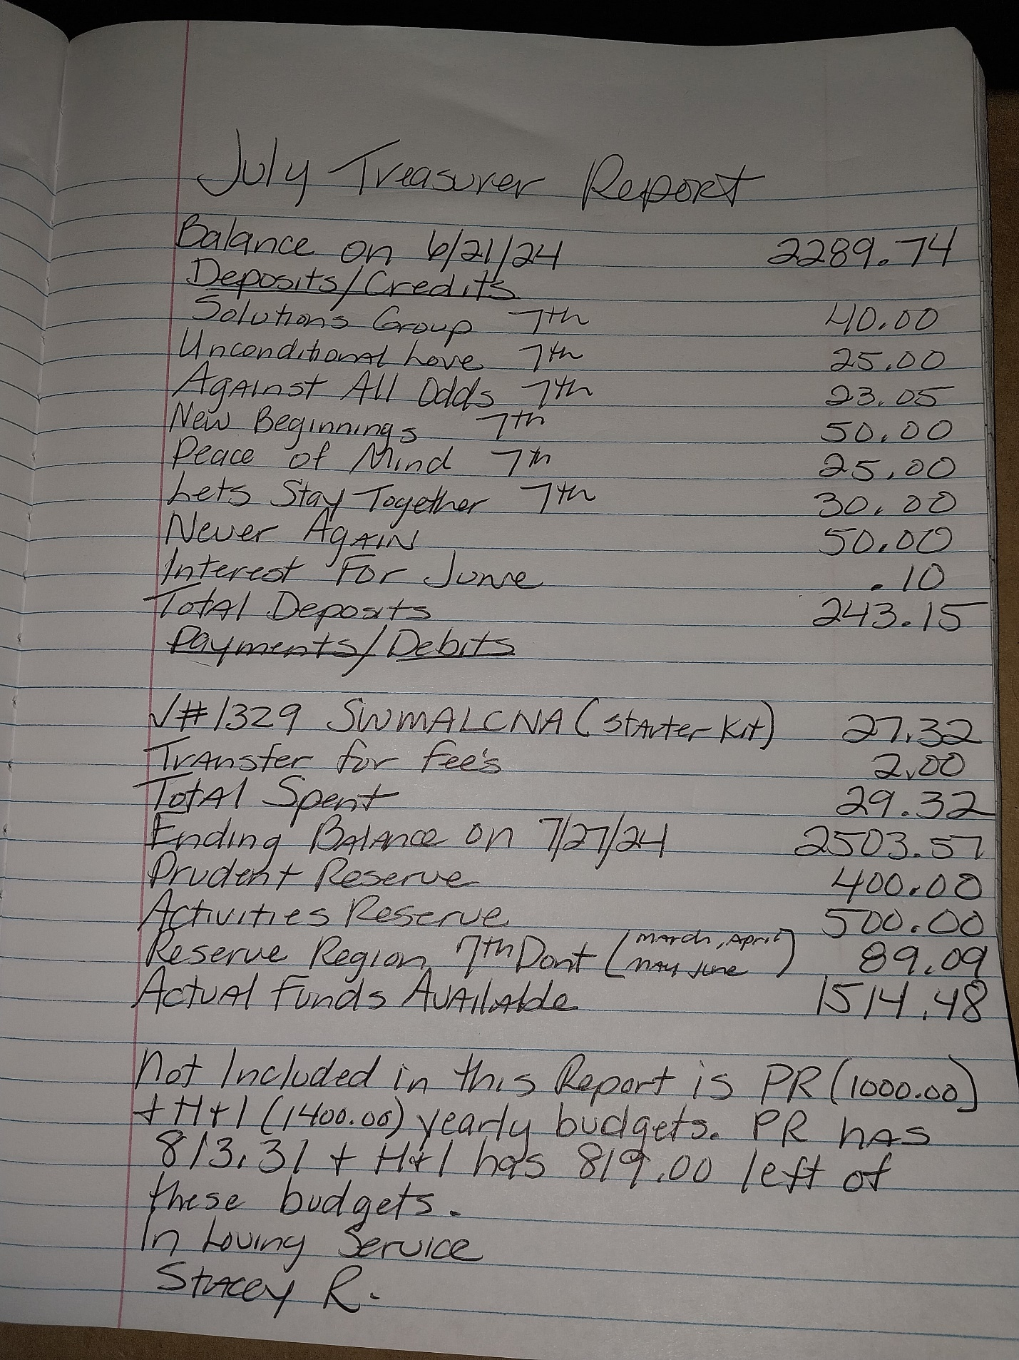

1. RCM: Brian: None
2. Sub-committee
3. Public Relations: Kim:

**July 2024 PR Report**

Area PR

September is National Recovery Month! Here are some events that we are registered for/will be registering for asap:

Gretchen - share on the Mother’s of Hope Recovery Walk on August 3rd?

9/14/24: Recovery Institute’s Recovery Fair, Bronson Park, 11am - 3pm

I have registered NA for this event, the cost is $80 for a table

9/21/24: Gryphon Place Suicide Prevention Walk, Bronson Park, 10am Kickoff

More information requested

9/28/2024: Carol’s Hope Recovery Life Rally, Carol’s Hope St. Joseph, 11am-3pm

More info requested from Carol’s Hope friend!

1. H&I: Dameion & Steve-o:

Southwest Michigan H&I Chair Report for 7-28-24 By Dameion G.

* Men’s and Women’s K-Pep in Kalamazoo on Chicago St. really needs volunteers who have the willingness to come I and carry the message of recovery. Please call or text Dameion at 269-348-6103. He goes up there a lot to make sure the residents have supplies. He has two recovering addict females doing meetings once a month. The male residents are holding their own meetings, and they would really like some recovering addicts to come in to assist with meetings.
* Kalamazoo County Jail is also in need of Male and Female volunteers who have the willingness to do H&I service. If you are interested please call Nick H. at 269-509-7272 for the male side and Trina H. at 269-248-2961 for the female side.
* Gilmore Treatment Center – From Kat C.: Coordinator: Hi Family, I’m and addict named Kat. Things have been going well at H&I. We finally have enough addicts to cover the schedule for both Friday and Sunday. However it would be such a blessing to have additional people as fill-ins meaning alternates in case of call-ins.

1. Literature: Patti:

S.W.M.A.S.C.N.A

Southwest Michigan Area Service Committee of Narcotics Anonymous

Literature Report

Meeting Location: Dowagiac

Committee Meeting Day / Time: 7/28/2024 3:00PM

CONTACT INFORMATION

CHAIR: Patti K PHONE: 269-806-3142 EMAIL: swmich.literature@michigan-na.org ormspattik@yahoo.com

Last month’s sales equaled: $785.60

Literature Purchased last month: $ 1460.15

MSO $ 1347.23

Shipping $102.08

IP Discount $4.20

Bulk Discount $61.25

Tax $76.92

Total Order $1460.78

Bank $688.41

Cash Box $200

Total Money: $888.41

Literature Value $4793.62

Hello Family: Happy Sunday to you all. To start off I want to say that there is a $15.67 difference in our bulk discount and the tax. I have reached out to MSO to find out why. Its supposed to clear each other out. Also shipping is enormous because I ordered forty-nine basic texts. Suuuper heavy. Thank you all for your pre orders. I have twelve. That is amazing.

Another thing I discovered when I was ordering the JFT journals is that they cost more than I was charging. My apologies to those who purchase them moving forward. I was charging $14 they are actually $20. That is what I will be charging. The order form online has been updated. Even though I didn’t change the date at the top of the order form. Oops The mini It Works How and Why are on back order. The Let’s stay together group ordered it. No official word on the Step writing bundle release. I thought it was at the World convention. However I am not so sure.

As usual Thank you all for your selfless service. And Thank you for letting me serve.

Here is a survey about step guide material. The World Services is surveying the fellowship please take a few minutes to do the survey. https://www.surveymonkey.com/r/step_working_material

Also below are the web addresses of our website and meeting list.

Website: https://michigan-na.org/southwest-michigan-area/

Meeting List: https://michigan-na.org/southwest-michigan-area/meetings/

1. Outreach: David:

7/30/2024

Outreach Report

David H.

July Area Meeting

Hello all,

Thank you everyone for continuing to let me be of service another month. Here’s my reporting for this month. This past month I went to the Monday night 7:00pm Feel The Love homegroup in Kalamazoo (the love was not felt), had an incident with the chairperson and wound up having to leave the meeting early. Me and another recovering addict went out to the 2 nd Chance Group in Paw Paw, thinking that it was at 6:00pm, not 7:00pm, when we got there, there was an NA meeting there (well, people leaving with NA books) that was just getting out that started at 5:00pm. Turns out the meeting was a group called Double Trouble in Recovery (DTR) and is a “blended” fellowship, rooted in AA that is designed for those who identify as co-occurring. They meet every Sunday at 5:00pm. The monthly calendar for the Daily Recovery Zone is on the New Associations Facebook Page.

I also tried to go to the Sunday night More Will Be Revealed group in Kalamazoo at 6:30pm and was unable to access the location due to various construction in the area. I brought this up during the Area meeting and Patti reached out to a homegroup member there and confirmed that they were still meeting.

Unity Group on Saturdays at noon in Kalamazoo is still around. I went for the first time, and they started several minutes late but eventually were up and running and still using their Hybrid format. They could always use more support.

The Southside group in Kalamazoo (Sundays at 3:00pm) is closed until further notice. I reached out to the GSR to confirm, and they are apparently dealing with some construction concerns with the building itself. We may want to think about removing this from the list for the time being. Some areas have a requirement that they must exist as a HomeGroup for 90 days before they can be on the meeting list. Is that the case for our area as well? I’ll get some more clarification on this moving forward.

I revisited some concerns I had with the communication during the last area meeting and some trusted servants, which made it difficult for me to envision pursuing my current position for another term as I will be devoting time doing service for MRCNA 39 and 40. I have faith that my higher power will continue to prevail and that my willingness may also improve in the months to come. In the meantime, I will be actively looking for a replacement during nominations this year, starting next month.

Thanks again, for letting me be of service.

Best,

David H.

269-716-8046

1. Activities: OPEN:
2. Old Business:
3. Open Positions: Co-Literature, Regional Committee Member Alternate (RCMA),

Activities Coordinator, Co-Public Relations (Co-PR)

1. Area Committee meetings will remain monthly until a GSR brings to the Area Committee that their group would like the Area meetings to be every other month or six times per year.
2. New Business:
3. * There is a new Women’s Meeting taking place on Friday evenings at 6pm at the River Church – 517 Walbridge St. – Kalamazoo – MI *
4. Nominations start in August!! Remember that the person needs to be present to be nominated for a position. The Area meetings will also be a little longer than normal for the next two months as we will be going over what the requirements and qualifications are for all of the different service positions on the Area Committee.
5. Area Committee Meetings for the next quarter (October, November and December) will be held in Three Rivers, unless a family member has another location that they would like to present to the Committee for consideration.
6. Home Group Reports:

Home group reports are available in the PDF file that is attached to the email where these minutes are found.

1. Close with a moment of silence and the We version of the Serenity Prayer.