SOUTHWEST MICHIGAN AREA OF NARCOTICS ANONYMOUS SERVICE COMMITTEE MEETING MINUTES
JUNE 23, 2024
AGENDA
- Moment of Silence: Uriah
- Service Prayer: Aaryn
- Traditions: Amber
- Concepts: Chris
- Roll Call: Emily

Position | Name | Present/Absent | Position | Name | Present/Absent
CHAIR: | Uriah C. | P | RCM | Brian C. | P
CO-CHAIR: | Derek | P | RCMA: | OPEN | NA
SECRETARY: | Emily N. | P | PR | Kim G. | A
CO-SECRETARY: | Samantha | P | CO-PR | Gretchen | P
TREASURER: | Stacey R. | P | Outreach | David H. | P
CO-TREASURER: | Angleline S. | P | ACTIVITIES: | OPEN | NA
LITERATURE: | Patti K. | P | H&I | Dameion G. | P
CO-LITERATURE: | OPEN | NA | CO-H&I | Steve-o L. | P

Attendees present that are not GSR or Officers: |  |  | Scott, Michael, Deb, Aaryn, Samantha
 |  |  | Chris, Jordan, Amber

Present Home groups:
Group Name | GSR/GSRA | Present or Absent
2nd Chances | Eric
911 | Brian C. | P
A New Way | David H.
Acceptance | Kim G.
Against All odds | Stacey | P
Any Lengths | Patti K. | P
Believers | Scott C.
Buchanan Fellowship | Todd L.
Choices | Mike
Daughters of Hope
Dinosaurs | LeRoy
Early Birds
Feel the Love
Keep Coming Back | Craig | P
Let's Stay Together | Antonio | P
More will be Revealed
Never Again | Rick | P
New Beginnings | Danielle | P
New Hope | LeRoy
New Life | Joe
Night Owls
North Side | Susan
Nothing to Fear | Emily N. | P
Pathfinders | Kristina
Peace of Mind | Neil | P
Recovery in the Vine | Matt | P
Similarities | Steve-o L. | P
Solutions | Derek | P
South Side Group | Tarsha
Step Sisters
Steppin' Up | Darren C.
Subject to Change | Kevin H.
Unconditional Love | Dameion G. | P
Unity | Andy
You’re Not Alone | Vic K.

- Open Sharing:
* There is a new Women’s Meeting taking place on Friday evenings at 6pm at the River Church – 517 Walbridge St. – Kalamazoo – MI *

- Approval of Prior Months Minutes: April – Approved & May – Approved

- Chair Report: Uriah: None

- Secretary Report: Emily: 600 Meeting Lists were ordered Wednesday June 19th but due to a family emergency, D&D Printing closed early on Friday June 21st and therefore the meeting lists were unavailable for the Area Meeting on Sunday the 23rd The secretary states that she will connect with Dameion from H&I and David from Outreach to ensure they have all the lists that they need. The box of meeting lists will also be at several meetings around Kalamazoo over the next couple of weeks. If you need meeting lists send the secretary an email(SWMANASecretary@gmail.com) and we will get some to you. Thanks for your understanding and accommodations. Thank you for allowing me to serve – Emily

- Treasurer Report: Stacey:

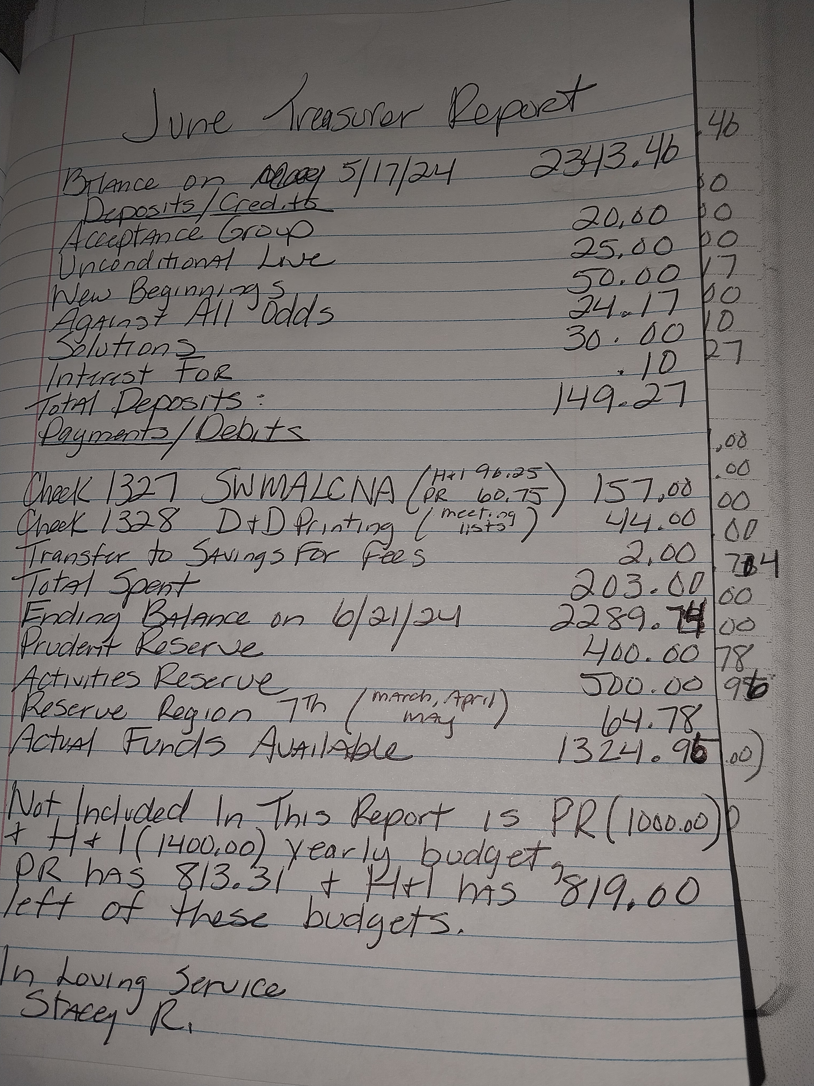

- RCM: Brian: None

- Sub-committee

- Public Relations: Kim & Gretchen:
- Recovery Walk – Mother’s of Hope – Kalamazoo – August 3 – 10a - More to be revealed!!

- H&I: Dameion & Steve-o:
- Nick H. is the new coordinator for the Men’s portion of the Kalamazoo County Jail!! If you need to contact him his number is 269-509-7272. Thanks, Nick, for stepping up and taking on this service position!!!
- KPEP Kalamazoo on Chicago St., and the Kalamazoo County Jail still need male and female volunteers who have the willingness to do service work.

- Literature: Patti:

S.W.M.A.S.C.N.A
Southwest Michigan Area Service Committee Of Narcotics Anonymous
Literature Report
Meeting Location: Dowagiac
Committee Meeting Day / Time: 6/23/2024 3:00PM
CONTACT INFORMATION
CHAIR: Patti K PHONE: 269-806-3142 EMAIL: swmich.literature@michigan-na.org or
mspattik@yahoo.com
Last month’s sales equaled: $442.40
Literature Purchased last month: $ 559.01
MSO $ 552.40
Shipping $55.24
IP Discount $48.62
Bulk Discount $33.14
Tax $33.15
Total Order $559.01
Bank $472.09
Cash Box $60.00
Total Money: $532.09
Literature Value $4225.77
Hello Family: Happy Sunday to you all. First of all I added the tax and bulk discount to the report because that is how MSO bills and its important. Also The bank and the order are different as I ordered based on orders that came in. I appreciate all the pre orders. It makes it a lot less chaotic at area.
Today I brought keytags and medallions and few books. Please continue to pre order as I don’t know from month to month what I am going to bring besides the preorders. There isn’t much more to report. However I will reserve the chance to share more if it arises. Thank you all for your service .. and thanks for letting me serve ILS Patti K
Just a quick Webservant report. As I know I fall under PR maybe Kim and I can chat before area and she can report…I don’t know as there isn’t a lot to report. I have been getting monthly updates to the virtual meeting list for the region. I thought we were done with updates from naws however I don’t think they have a mechanism in place for virtual meetings. I will continue to serve and update and post. Let me know if you have flyers or news you would like to be on our Southwest website. Also If anyone would like to be shown how to access our actual website please reach out. I feel like a lot of people go to Michigan-na.org and our confused why our stuff isn’t there. Unfortunately there are a few steps to take to get to our website and meeting list. Once you know it you know it and its easy.. I was confused at first when I started using it. I often get asked for meeting information and that is fine keep asking.. I usually send a link to the meeting list.
That link is active and in real time and up to date whether accessing it today or in a month. I hope that has been helpful.. I can also send links to our website. Below is a link to both. Thanks for letting me serve.
Website: https://michigan-na.org/southwest-michigan-area/
Meeting List: https://michigan-na.org/southwest-michigan-area/meetings/

- Outreach: David:
- There was a lot of discussion about the Outreach position at the Area Meeting this month. Questions about the scope of the position and what is required of the individual who is the Outreach coordinator were some of what was talked about. After a very lengthy discussion and vote the Area committee has decided that David will be allowed to have $200 to purchase NA literature (2-4 of each of our books). He will then have this literature with him when he goes to visit the smaller and more rural meetings in our Area. If they need literature and are unable to get to the monthly Area meeting for whatever reason, David would be able to provide them with any NA literature they might need. This will be on a trial basis over the next few months and then we will reevaluate to see how the program is working.

- Activities: OPEN:

- Old Business:

- Open Positions: Co-Literature, Regional Committee Member Alternate (RCMA),
Activities Coordinator

- Samantha was voted in as the new Co-Secretary for the Area Committee!

- New Business:

- Vote Regarding Meeting Six Times per Year = No Consensus
There was a long discussion about the pros and cons of meeting every other month vs. every month as we do now. Everyone had a chance to voice their opinions in an orderly and professional manner. Since no consensus was reached when the vote was taken this matter will be tabled for now.

- Vote Regarding Home Group Report Sheets = Consensus – Yes
The Area Committee had a lengthy talk about having home groups fill out a simple report sheet. Group Service Representatives (GSR’s) would bring these to the Area meeting. The Secretary would compile them and add them to the monthly minutes. This should open a line of communication between the Area Committee and the Home Groups. These report sheets will give the Home Groups a way to tell the Area Committee if they have any needs or if there is anything that the Committee can help them with. These report sheets should, in theory, increase the amount of communication between the Home Groups and the Area Committee. This will make it easier for Area to serve the groups by better understanding their needs. There will be copies of a completed report sheet and a couple of blank report sheets that have been used in the past at the end of the minutes. The current secretary would like to revise the report sheets to be a little more relevant and contain more information about how the groups are doing and what they need from the Area Committee.

- Home Group Reports:
Keep Coming Back: This meeting is just getting started – attendance is improving. They may be changing locations?!
Let’s Stay Together: Attendance is improving – they are thinking about having a speaker event!
New Beginnings: Feels like the Area meeting is getting rushed through and that Home Groups are not getting heard.
Nothing to Fear: Good attendance. Twisted & Tasty Topics – 2nd Tuesday of every month, bring your favorite finger foods and spin the wheel for your talking topic! Lots of fun!!
Similarities: Back to five days a week (Monday-Friday), meeting is doing really well, need to get a bank account for their 7th tradition!
Solutions: Tuesday – Literature Study – 15-20 people, Saturday – Rotating Format 20-30 people
911: Going Great getting approx. 30-35 people per meeting, need to clean the carpets in the church – someone spills something every week.

- Close with a moment of silence and the We version of the Serenity Prayer.

